**Implementation of Procure to pay Cycle**

Though this process is not specific to oracle ERP system, screen shots shown in the below are from Oracle ERP.

* Create Requisition
* Create Purchase Ordera
* Create Inventory Receipt
* Enter AP Invoice
* Make Payment
* Transfer to GL

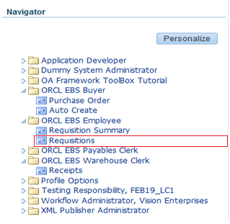

Step 1.

Start from ORCL EBS Employee Responsibilty.

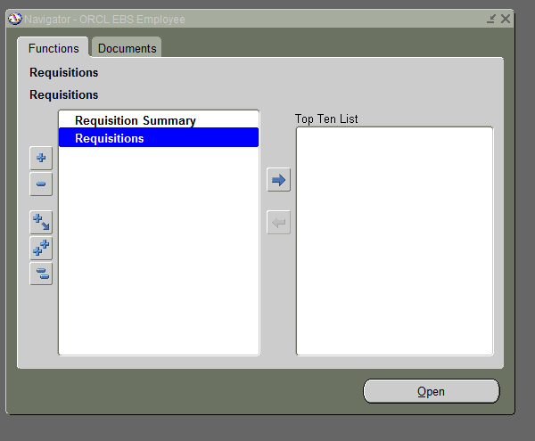

Step 2.

Click on requisitions to move further

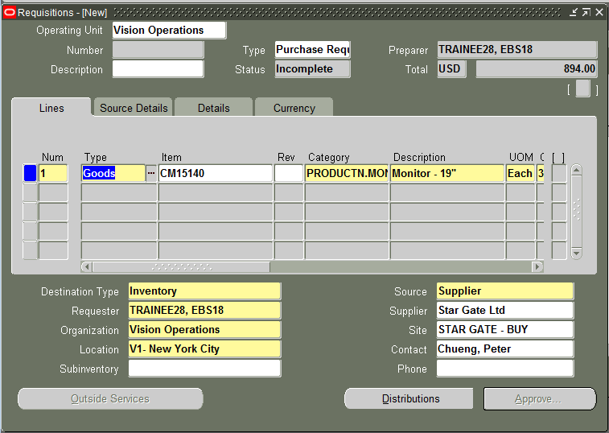

Step 3.

Fill Item and Quantity then Save Requisition by Ctrl+ S.

We can save the requisition number at this stage.

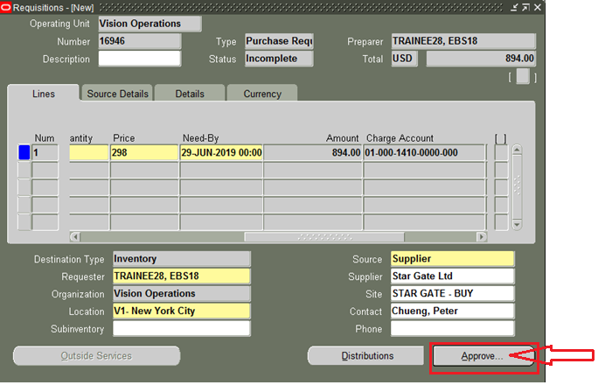

Step 4.

Note down the Requisitions Number: 16946 then Click Approve button and Submit for Approval

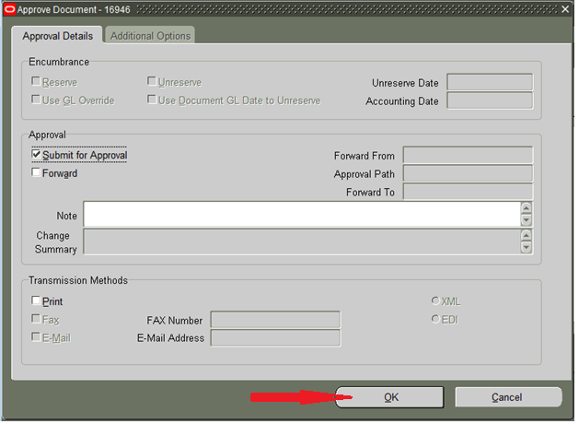

Once requisition is approved we will not be able to open the requisition again. We can check the requisition details in Requisition summary form.

**Responsibility changed:**

**Navigation: Purchasing Responsibility > Auto Create**

Step 5.

Click on hat symbol and change responsibility to ORCL EBS Buyer.

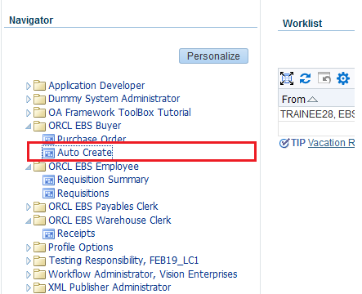

Click on Auto Create Responsibility to move:-

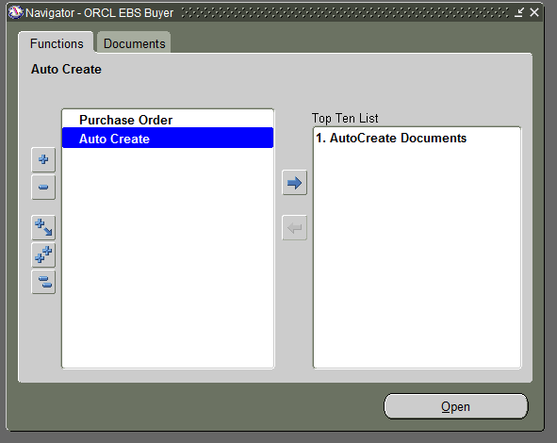

Step 6.

Enter requisition number: 16946 which is saved and hit TAB to ensure you requisition is valid.

Make sure we empty the Ship-To and Buyer fields as it might add un-necessary condition to our search query.

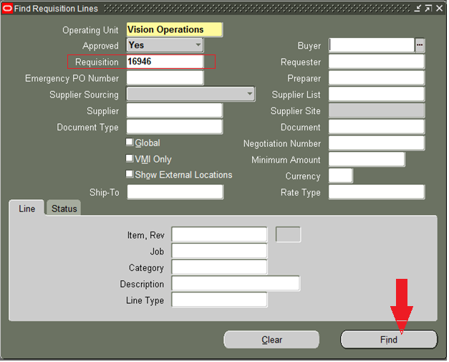

Step 7.

Once we find the requisition select it by enabling the checkbox and choose the type of document we want to create.

In this example we are converting requisition into “Standard Purchase Order”.

We also have the option to convert requisition into RFQ.

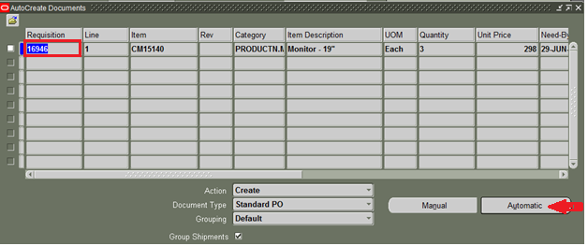

Step 8.

We choose automatic because we wish to convert this single requisition into one purchase order.

Step 9.

In the below screen we can choose the supplier and supplier site. If we skip here we will need to enter on Purchase Order form before we submit PO for approval.

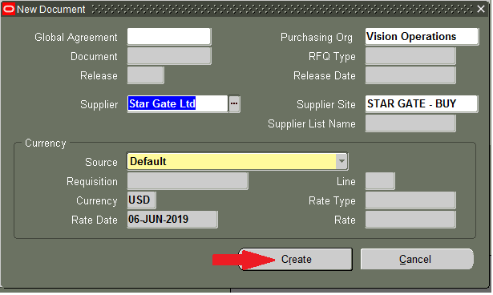

Step 10.

Once we click on Create button all requisition information is transferred to Purchase Order Form.

Select Ship-To field carefully as this is required to create inventory receipt / purchasing receipt.

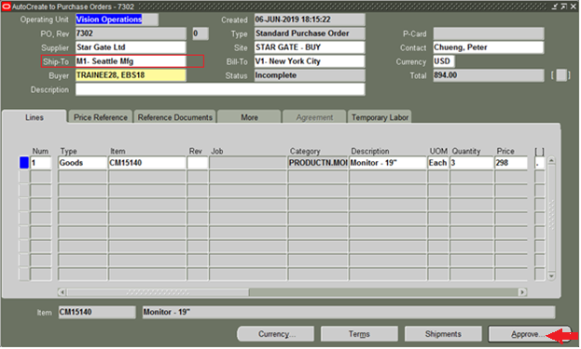

Step 11.

Click Approve button and submit for approval. Assuming that we have enough $ limit or it is approved by concerned person we will move on to next step.

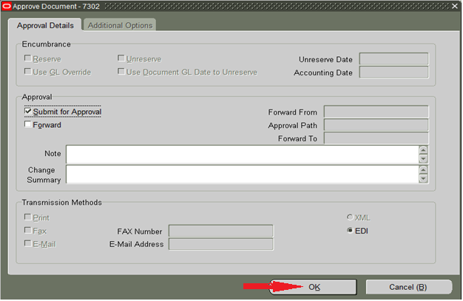

Step 12.

Now PO being sent to Supplier. we can expect the products to be delivered to us. Once items / products are delivered to us we will create Receipt to record the details of the products received.

**Change responsibility:-**

**Navigation: Purchasing Responsibility > Receiving > Receipts**

Step 13.

We can create Receipt in purchasing module or inventory module.

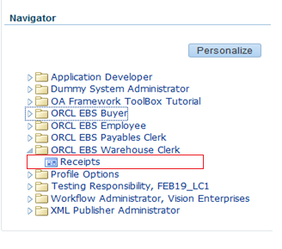

In the FIND field click on ‘Ship-to’ to Purchase order.

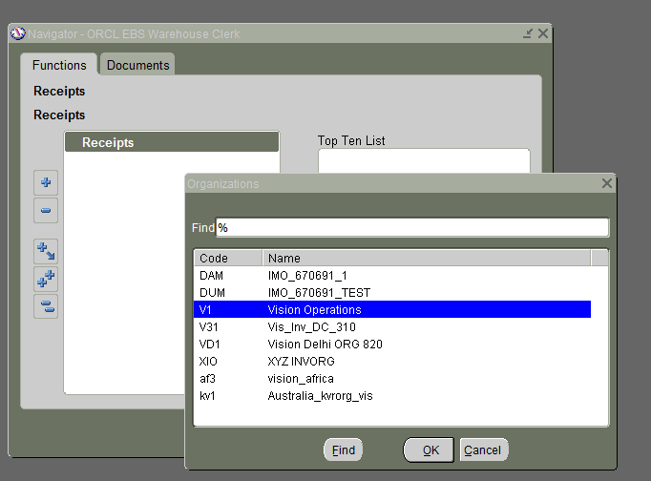

Step 14.

Select the organization that we have selected in “Ship-To” filled of Purchase order

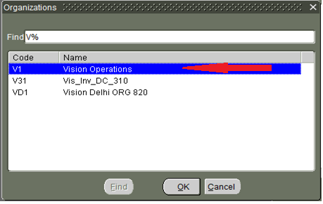

Step 15.

Enter the Purchase order number: 7302 on find screen and find it.

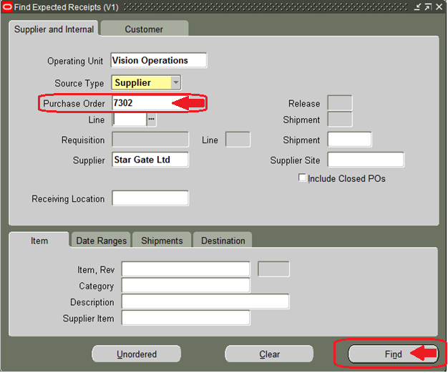

Step 16.

If our PO is found then it will open “Receipt Header” and “Receipts” form.

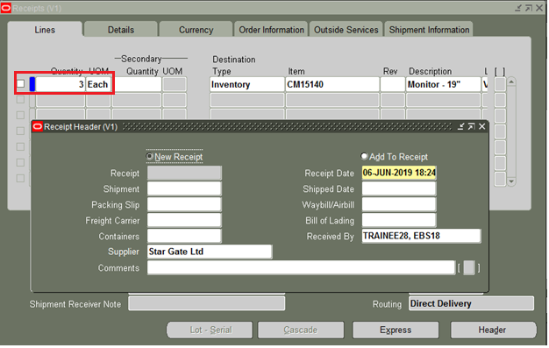

Step 17.

Move Receipt Header form side and check the line we would like to receive.

If sub inventory is not defaulted automatically choose sub inventory in which we would like to receive the material like FGI, Stores etc.

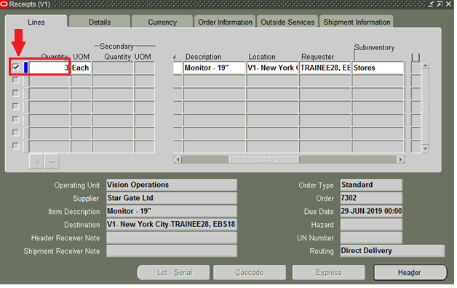

Step 18.

Once we enter all the information. We have to sure to Save the Receipt.

Once we create a receipt for PO we will not be allowed to create another receipt for the same PO. It is allowed only in case of partial receipts.

Along with items / products supplier will also send Invoice asking for payment.

**Change Responsibility**

**Navigation: Payables Responsibility > Invoices > Entry > Invoices**

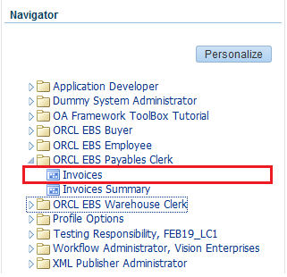

Step 19.

Enter the information as per the document (Invoice) received from supplier

And

Once the header information is entered we will match the invoice with purchase order by clicking Match button.

Enter Purchase Order Number and Find it.

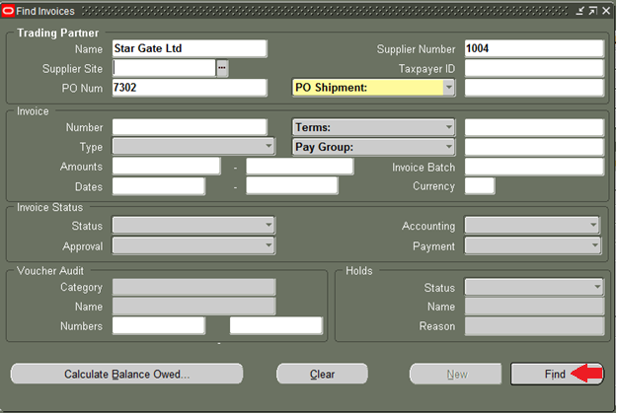

Step 20.

Once the PO is found select the “Match” checkbox and click Match button at the bottom.

Step 21:

Once the PO is matched we can see the Total amount in General Tab as shown below.

Click Calculate Tax button to add any tax if it is applicable.

The total amount on header should be equal to total of line amounts.

Step 22:

Click Actions Button and Select Validate option and also click on calculate tax button after Actions button.

Step 23:

Make sure Invoice is validated correctly as shown below.

Step 24:

Again click on Actions button and this time select “Create Accounting” option. Choose Final Post to send accounting information directly to GL and post.

Step 25:

Once accounting is successful we will be greeted with the following message.

Step 26:

Now in General Tab of Invoice we should be able to see the Status as below.

Step 27:

Normally any company will wait for the due date to make payment. If we choose to pay ahead also we can pay it.

**Change Responsibility:**

**Navigation: Scheduled Payments > Pay.1.**

Step 28:

Payments form will open as shown below.

Enter Payment Method and payment process profile details.

Step 29:

Save our payment by clicking SAVE button.

Step 30:

Once payment is done we need to create accounting.

Click Actions button and select Final Post.

Step 31:

Finally, Make sure our payment is recorded in “View Payments” tab of our invoice. We might need to re-query your invoice to see this information.